- Statistics is the branch of mathematics that deals with collecting, organizing, analyzing, interpreting data to support decision-making or gain insights.
- Data is of 2 types.
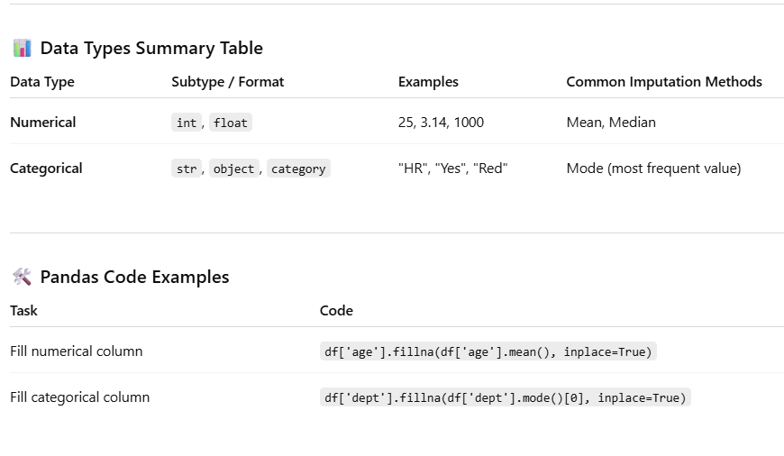
- SAMPLING
- Sampling is the process of selecting a subset of data (called a sample) from a larger group (called a population) to analyze and make inferences without using the entire dataset.
Random Sampling
Random sampling means selecting rows randomly from the entire dataset, where each record has an equal chance of being selected.

📌 When to Use:
- The data is evenly distributed (not skewed).
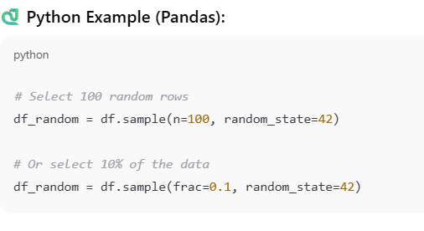
Stratified Sampling
Stratified sampling involves dividing the data into groups and then randomly select data from each group so their proportion in the sample matches the original dataset.
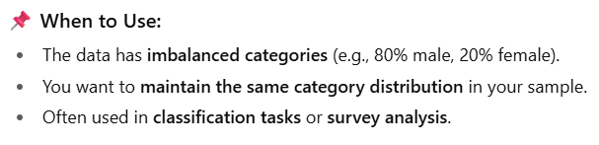
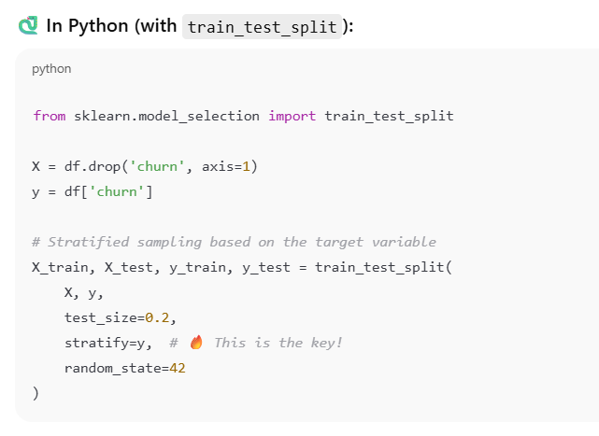
📘 Central Tendency
It refers to the central value in a dataset — a way to describe where most values in a distribution fall.
The three most common measures are mean, median, and mode.
For interview:
- How do you handle missing values?
If the column is numerical and has no outliers, I impute missing values with the mean.
If it's skewed or has outliers, I use the median. For categorical data, I use the mode.”
- always check the distribution of the data (e.g., using histograms or boxplots) before deciding which measure of central tendency is most appropriate.”
- Std. Deviation & Variance
Variance and standard deviation measure how much the data values spread out from the mean.
They help us understand the variability in the data — whether the values are tightly clustered or widely scattered around the average

Use Case Overview
"Let’s say we’re analyzing monthly sales. Two stores may have the same average sales (mean), but one may have sales ranging from 100–900, while the other is consistently between 480–520."
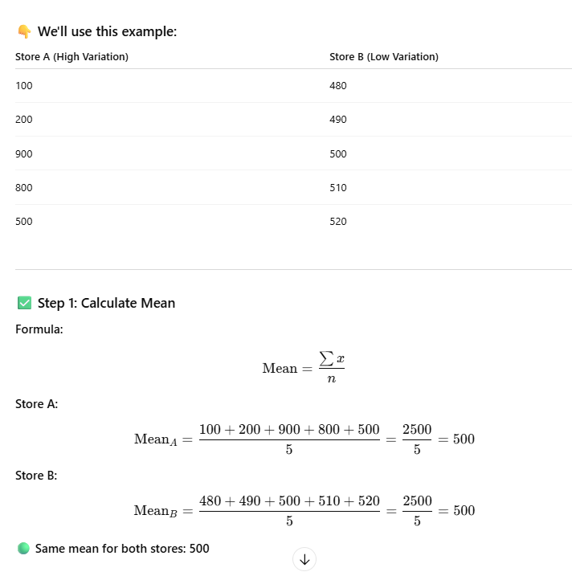
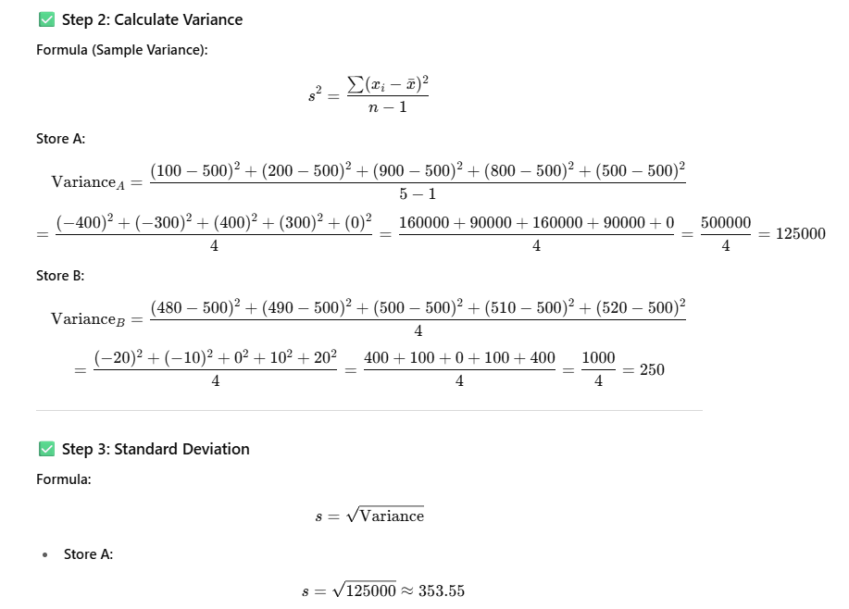
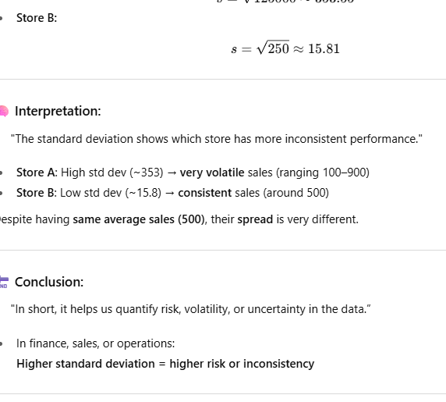
Can’t we just use variance instead of standard deviation?"
You can say:
“Yes, both measure spread, but variance is in squared units, while standard deviation is in the same unit as the data, making it easier to interpret and explain to stakeholders.”

